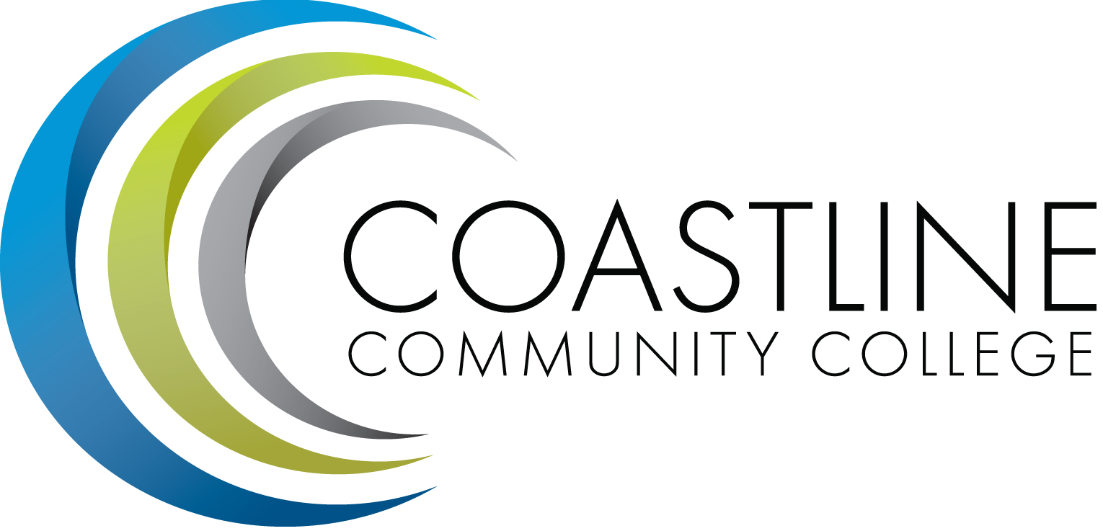
Coastline Management Meeting (CMT) Minutes - DRAFT
June 7, 2016
9:00 – 11:00 a.m.
4th Floor Conference Room

Name | Present | Name | Present | Name | Present
Adrian, Lori | X | Harrison, Nate | X | Nash, Bob | X
Akins, Renate | X | Holliday, Ann | X | Nguyen, Christine | X
Blackmore, Chris | X | Johnson, Nhadira | ABS | Rodriguez, Vince | EXC
Brais, Nathan | EXC | Jones, Nancy | X | Rothgeb, Helen | X
Cant, Dave | ABS | Keeler, Bruce | X | Sanchez, Jorge | X
Capoccia-White, Rozanne | X | Khosravani, Mariam | EXC | Scott, Michael | EXC
Dahnke, Lynn | ABS | Le, Mai | X | Staneart, David | X
De La Rosa, Jennifer | X | Maharaj, Peter | X | Thompson, Dave | EXC
Emerson, Dana | X | McDonald, Jennifer | X | Woodyard, Steve | X
Garvey, Judy | X | Mendez, Julie | X | Worden, Mark | X
Groot, Joycelyn | X | Miyashiro, Ross | X | Zentner, Aeron | X
Halvorson, Mary | X
Guests: Ann Nicholson, Kevin Donahue, Nate Banditelli, Elaine Hill
Recorder: Kathy Surgenor

- CALL TO ORDER
  - Roll Call
  - Welcome: Chair, President Lori Adrian welcomed the committee and introduced guests.
  - *Adoption of June 7, 2016 Agenda Adopted MSU (w/amendments)
  - *Approval of May 3, 2016 Minutes DEFERRED TO NEXT MEETING

- SPECIAL REPORTS & UPDATES
2.1 CFCE Contract – A. Nicholson (15 minutes) – Ann Nicholson provided a report on the CFCE Contract and explained Student Assistant scheduling of hours and clarified new language of a probationary employee. She also discussed the intention, timelines and appeal process for Performance Evaluations. Ann reviewed Leave of Absence reporting and Professional Growth (Professional Development) language and guidelines. A discussion ensued amongst the committee regarding vacation requests and seniority requirements. Classified Senate will work with CFCE to promote professional development opportunities for staff. Any further questions should be submitted directly to Ann Nicholson.
2.2 New Purchasing Processes – H. Rothgeb – Helen advised that new software (Great Plains) and a new automated travel request is in process. Updates will be sent via E-mail.

- ACTION ITEMS
3.1 From March 1, 2015 Meeting (new items):
3.1.1 All members will review Focus Survey results and provide feedback to Aeron by or before the next CMT meeting on April 5 for finalization of the document. DEFERRED TO NEXT MEETING

  - From May 3, 2016 Meeting (new items):
    - The Instruction and Student Services Wing will develop a joint document to identifying two to three areas of focus and an action plan to complete their plan. Vince will provide copy of plan document at the next meeting in June. DEFERRED TO NEXT MEETING
    - Dana and Vince will confer with the Academic Senate to clarify the Senate’s request for definitions and expectations of the Civitas program. They will provide a report at the next meeting in June. DEFERRED TO NEXT MEETING

- DISCUSSION ITEMS
4.1 TED Talk – “Where do Ideas Come From” – B. Keeler, P. Maharaj – Bruce and Peter provided a slide presentation and discussed ideas for innovation and how new ideas are formed. The committee was divided up into groups to brainstorm and identify barriers and ideas in pursuing innovative processes. Some barriers for creativity outlined and discussed were:

- Time Management
- Structure, Purpose and Composition of Meetings
- Interconnectedness
- Sharing of Information/Communication
- Trust Issues
- Sustainability of Ideas/Action Plans
- Physical Meeting Space
- Overload of Paperwork
- Deadline Overlap
- Time Constraints
- Initiatives & Regulations
- Political/Bureaucracy Issues
- Risk Taking
- Lack of Communication within the college
- Clear Goals and Priorities

Peter presented and discussed a camera that could provide photos/video and feedback for innovative processes. Aeron proposed developing and using an Idea form.
4.2 Summer Managers Retreat – L. Adrian – Retreat will be held August 1-2. Dr. Adrian proposed two (2) books for reading to be discussed at retreat (“Leading Change” and “The Advantage”). Aeron suggested the option of attaining audio books. Books should be ordered by members personally; reimbursements for purchase can be submitted. Speakers will be identified and an agenda will be developed and sent to the committee prior to the Retreat.
4.3 2016 Fall All-College Meeting – L. Adrian - DEFERRED TO NEXT MEETING

5. HOT TOPICS

6. ANNOUNCEMENTS (1-2 minutes per)
6.1 No meeting will be held in July – Lori Adrian
6.2 Classified Senate Meeting/Installation Lunch will be held on Friday, June 10, 11:30a-1:30p, 4th Floor Conference Room – Elaine Hill
6.3 Summer Reception and Foundation Board of Directors Retreat will be held on July 29, 5:00p at the Newport Beach Center. Personal Invitations will be sent – M. Khosravani
7. ADJOURNMENT – Meeting adjourned at _________ a.m.

8. SUMMARY OF KEY ITEMS DISCUSSED/ACTIONS TAKEN
8.1 CFCE Contract Updates and New Language
8.2 New Purchasing Process
8.3 “Where Do Ideas Come From” Presentation/Ideas for Innovation
8.4 Summer Managers Retreat

10. CDMA – CLOSED SESSION
Documents Distributed:
- June 7, 2016 Agenda
- Draft of May 3, 2016 Meeting Minutes

Next Meeting: September 6, 2016, 9:00 a.m., 4th Floor Conference Room
*Attachment(s)

